## Blog

Write a program for reading blog content. It needs to make **requests** to the **server** and display **all blog posts** and their **comments**.  
Request URL’s:

Posts - **http://localhost:3030/jsonstore/blog/posts**

Comments - **http://localhost:3030/jsonstore/blog/comments**

The button with ID "**btnLoadPosts**" should make a GET request to "**/posts**". The **response** from the **server** will be an **Object of objects.**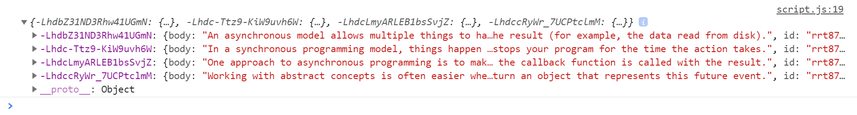

Each object will be in the following format:

{

body: {postBody},

id: {postId},

title: {postTitle}

}

Create an <option> for each post using its object key as value and current object title property as text inside the node with ID "**posts**".

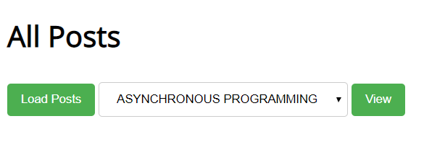

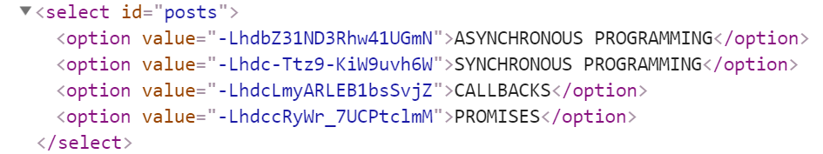

When the button with ID "**btnViewPost**" is clicked, a GET request should be made to:

* "**/comments/:id**" to obtain the selected post (from the dropdown menu with ID "**posts**") - The following **request** will return **a single object** as described above.
* "**/comments -** to obtain all comments. The request will **return** a **Object** of **objects**.

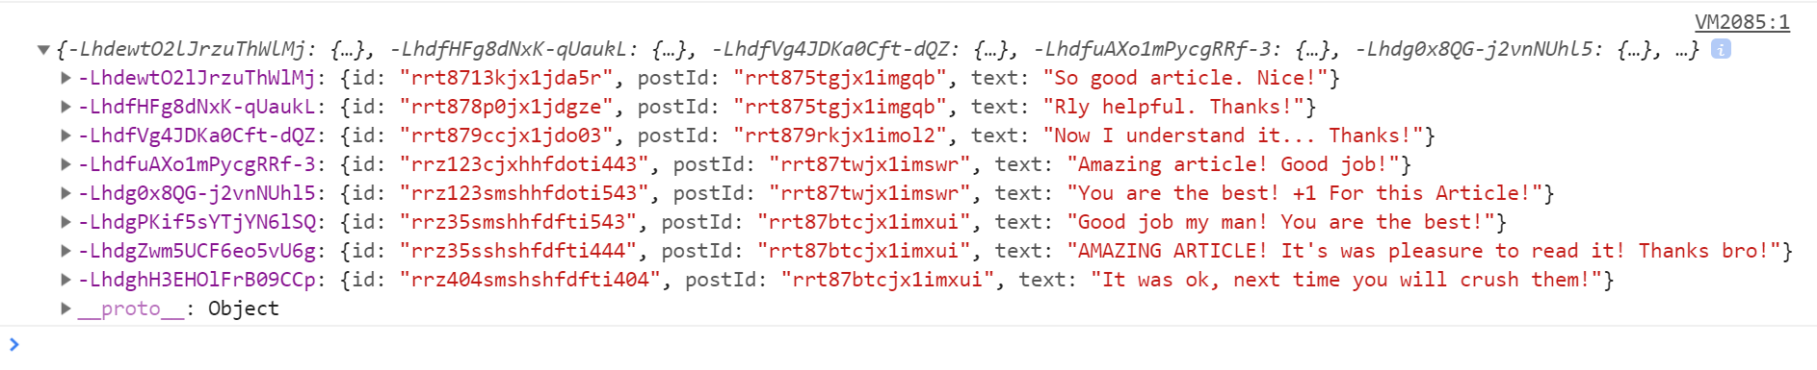

Each object will be in the following format:

{

id: {commentId},

postId: {postId},

text: {commentText}

}

You have to find this comments that are for the current post (check the postId property)

Display the post title inside **h1** with ID "**post-title**" and the post content inside **ul** with ID "**post-body**". Display **each comment** as a **<li>** inside **ul** with ID "**post-comments**". Do not forget to clear its content beforehand.

